DS.140 Integration Design Specification



Accrue on Receipt update Integration

SCM_RICE_357

Author: Pranjul Garg

Creation Date: May 20, 2022

Last Updated: May 20, 2022

Version: 1.0

**Approvals:**

|  |  |
| --- | --- |
| <Approver 1> | <Rakesh Khanna / Naushad / Amit> |
| <Approver 2> | <Business Owner> |

# Document Control

## Change Record

| Date | Author | Version | Change Reference |
| --- | --- | --- | --- |
| 20-May-2022 | Pranjul Garg | 1.0 | No Previous Document |
|  |  |  |  |
|  |  |  |  |
|  |  |  |  |

2

## Reviewers

| Name | Position |
| --- | --- |
| FHL Business | Business User |
| FHL IT Group | Fortis IT Team |
|  |  |
|  |  |

Contents

1 Document Control ii

1.1 Change Record ii

1.2 Reviewers ii

2 Introduction 4

2.1.1 Scope for this Document 4

2.1.2 Intended Audience 4

3 Overview 5

3.1 Business Objectives 5

3.2 Major Features 5

3.3 Glossary 5

4 High-Level Fusion Integration flow 6

5 Technical Design Details 7

5.1 OIC Services 7

5.2 Oracle PaaS DBCS components 8

5.3 Technical flow 8

6 Data FIELD Mapping 11

6.1 File format 11

6.2 Frequency 11

7 Exception handling 12

7.1 Scenarios 12

8 Assumptions / Considerations 13

9 Open and Closed Issues 14

9.1 Open Issues 14

9.2 Closed Issues 14

# Introduction

### Scope for this Document

This analysis specification document is prepared to layout the design for an integration to update the Accrue on Receipt flag on PO.

### Intended Audience

This document is intended for the following groups to provide the action items and consideration that are required to complete the implementation of the various Supply Chain and Finance related functionalities from Oracle Fusion.

#### Fortis Business Users

This document will be helpful for Fortis Business users to understand the technical design and process change with the new structure implemented in Oracle. The business user will validate this document after the verification of the requirement.

#### PwC Technical Team

The PwC technical team will use this document as a source technical design document to develop the technical solution to implement / deploy in Oracle Fusion.

#### Fortis IT Team

The Fortis IT Team must facilitate the PwC technical team for requisite details and other elements required from Business. The Fortis IT team is also responsible to arrange and provide required technical information wherever is required.

# Overview

Fortis Healthcare Limited (FHL) is a chain of hospitals, headquartered in India. Fortis started its health care operations from Mohali where first Fortis hospital was started. Later, the hospital chain purchased the healthcare branch of the Escorts group and increased its strength in various parts of the country. The Fortis health care also operates its hospital in Vasant Kunj, Faridabad, Gurgaon. The FMRI hospital at Gurgaon is the headquarter of Fortis healthcare with all the major facilities at the hospital.

This specification document is prepared to layout the design for an integration to update the Accrue on Receipt flag for PO, which have been generated for an agreement which is an AMC / CMC.

## Business Objectives

The following are the business objectives.

1. To have a secure, reliable, and scalable design flow to validate and process the transaction via OIC.
2. To have a solution providing the monitoring capabilities.

## Major Features

The proposed solution will have the following features involved:

1. OIC integration invokes Fusion BI report to fetch the eligible PO line where “Accrue on Receipt” flag has to be updated.
2. The OIC integration then invokes a REST API to update the PO line.

## Glossary

REST

Representational State Transfer.

OIC

Oracle Integration Cloud

# High-Level Fusion Integration flow

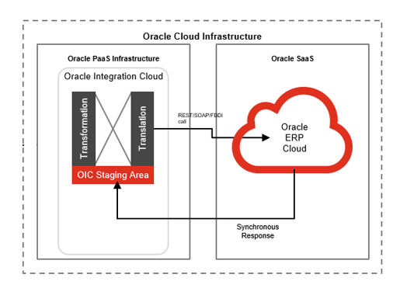

# Technical Design Details

This section describes the technical details of all the components involved in the design for an integration to auto cancel the PR line based on need by date.

## OIC Services

An App driven orchestration has been designed in OIC to build a REST Endpoint URL:

|  |  |
| --- | --- |
| **OIC Integration Name** | Fortis Trigger Accrue on Receipt Flag Update Intg |
| **OIC REST Endpoint URL** | <https://oic-prod-nr5lr39yailj-bo.integration.ocp.oraclecloud.com:443/ic/api/integration/v1/flows/rest/FORT_TRIG_ACCR_REC_FLAG_UPD_INTG/1.0/updateAccrueReceiptFlag/> |
| **Method** | POST |

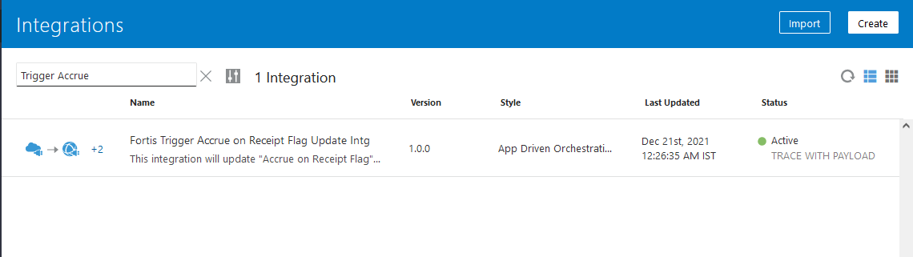

This is an app driven integration which is invoked via a following common scheduled OIC integration:

|  |  |
| --- | --- |
| **OIC Integration Name** | Fortis Trigger 30m Integration |
| **OIC REST Endpoint URL** | [NA](https://oic-prod-nr5lr39yailj-bo.integration.ocp.oraclecloud.com:443/ic/api/integration/v1/flows/rest/FORTIS_TRIG_GRN_PUT_AWAY_TXN_INT/1.0/grnPutAway/) |
| **Method** | NA |
| **Frequency** | Scheduled every 30 minutes |

This wrapper scheduled integration has been configured due to the limit of scheduled integrations within OIC. Hence all the required scheduled integrations have been clubbed together as per their required frequency.

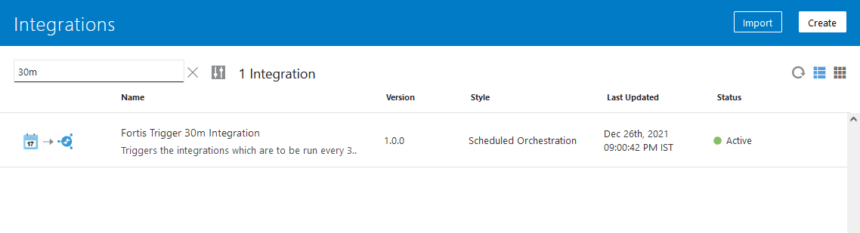

## Oracle PaaS DBCS components

This integration design does not use any DBCS related component.

## Technical flow

Following is the complete technical flow for this integration design:

1. A common scheduled OIC integration (Fortis Trigger 30m Integration) invokes this integration to update the Accrue on Receipt flag.
2. The OIC integration invokes ESS Job: Fortis Accrue on Receipt Flag ESS Job (path: /oracle/apps/ess/custom/oracle/apps/ess/custom/purchasing/) which internally invokes BI Report: Fortis Accrue Receipt Flag Check Report to fetch the eligible PO lines where the flag must be updated.
3. This BI report uses the following query to fetch the eligible PO Lines based on the logic where the item category is like ‘%AMC%CMC%’ and accrue on Receipt flag is ‘N’.

SELECT pha.prc_bu_id, plla.po_header_id, pha.segment1 po_number, pla.line_num,

plla.po_line_id, plla.line_location_id, 'DATA' KEY, pha.cancel_flag,

pha.approved_flag, pla.line_status

FROM po_headers_all pha,

po_lines_all pla,

po_line_locations_all plla,

egp_categories_vl ecv

WHERE pha.po_header_id = pla.po_header_id

AND pla.po_line_id = plla.po_line_id

AND pla.po_header_id = plla.po_header_id

AND NVL (plla.accrue_on_receipt_flag, 'N') = 'Y'

AND NVL (pha.cancel_flag, 'N') = 'N'

AND NVL (pha.approved_flag, 'N') = 'Y'

AND pla.line_status = 'OPEN'

AND NVL (plla.quantity_received, 0) = 0

AND pla.category_id = ecv.category_id

AND ecv.category_code LIKE 'SERVICE%AMC/CMC%'

AND NOT EXISTS (

SELECT 1

FROM po_doc_style_headers pdsh

WHERE pha.style_id = pdsh.style_id

AND pdsh.style_name LIKE 'Consign%')

AND NOT EXISTS (

SELECT 1

FROM po_headers_draft_all phda

WHERE phda.po_header_id = pha.po_header_id

AND phda.entity_change_type_code IN ('C','U')

AND phda.prc_bu_id = pha.prc_bu_id)

1. This OIC integration then invokes the following SOAP web service for changePurchaseOrder operation to update the Accrue on Receipt flag at the PO line schedule level. It also updates a static value (ACCRUE_RECEIPT_FLAG_INTG) in DFF at PO header level for each & every record:

|  |  |
| --- | --- |
| WSDL URL | <https://fa-ermg-saasfaprod1.fa.ocs.oraclecloud.com:443/fscmService/PurchaseOrderServiceV2?WSDL> |

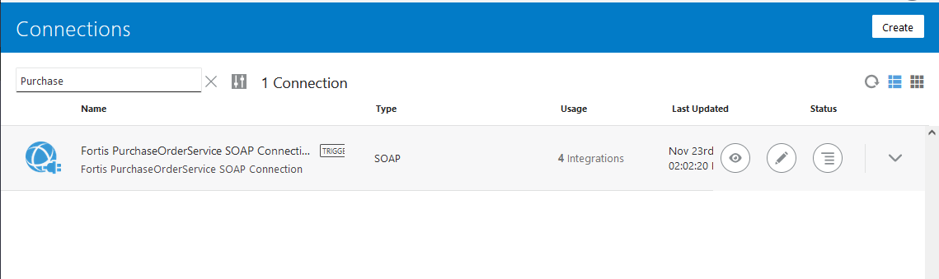

**Server details:**

|  |  |  |  |  |
| --- | --- | --- | --- | --- |
| **Server** | **Host name** | **Port** | **Service Name** | **Username** |
| Oracle PaaS DB | 140.238.225.129 | 1521 | PRODPDB1.fhpubsn.fhvcn.oraclevcn.com | XXFH & XXFH_RO |



# Data FIELD Mapping

NA

## File format

NA

## Frequency

The GRN Put away integration is scheduled to run every 30 minutes.

# Exception handling

There can be various scenarios for an error to occur. This section defines those error scenarios, and the exception handling has been done to notify and act accordingly.

## Scenarios

In a tabular format give list of scenarios and exception handling

* If any of the step or node fails within the OIC integration, Global Fault section is configured within this OIC integration to send an OIC error notification with relevant details.
* The email id has been stored in OIC Lookup: Fortis_FaultNotification_EmailAddress_Lookup against the given OIC integration name.
* It also sends a notification every 10 minutes with the details of the GRN which have been processed in the given run. This notification also acts as a confirmation that the integration has been running fine.

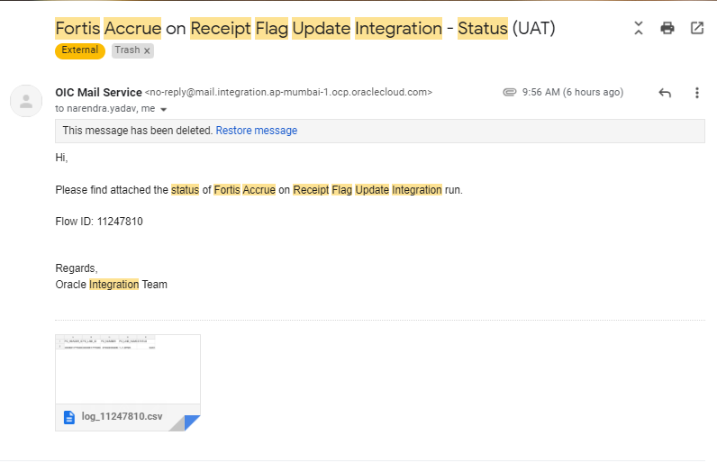

# Assumptions / Considerations

The Proposed Solution will have the following technical considerations.

In the future, if any product bug arises in functionality then this process needs to be revisited after the bug is fixed.

# Open and Closed Issues

## Open Issues

| ID | Issue | Resolution | Responsibility | Target Date | Impact Date |
| --- | --- | --- | --- | --- | --- |
|  |  |  |  |  |  |
|  |  |  |  |  |  |
|  |  |  |  |  |  |
|  |  |  |  |  |  |

## Closed Issues

| ID | Issue | Resolution | Responsibility | Target Date | Impact Date |
| --- | --- | --- | --- | --- | --- |
|  |  |  |  |  |  |
|  |  |  |  |  |  |
|  |  |  |  |  |  |
|  |  |  |  |  |  |